**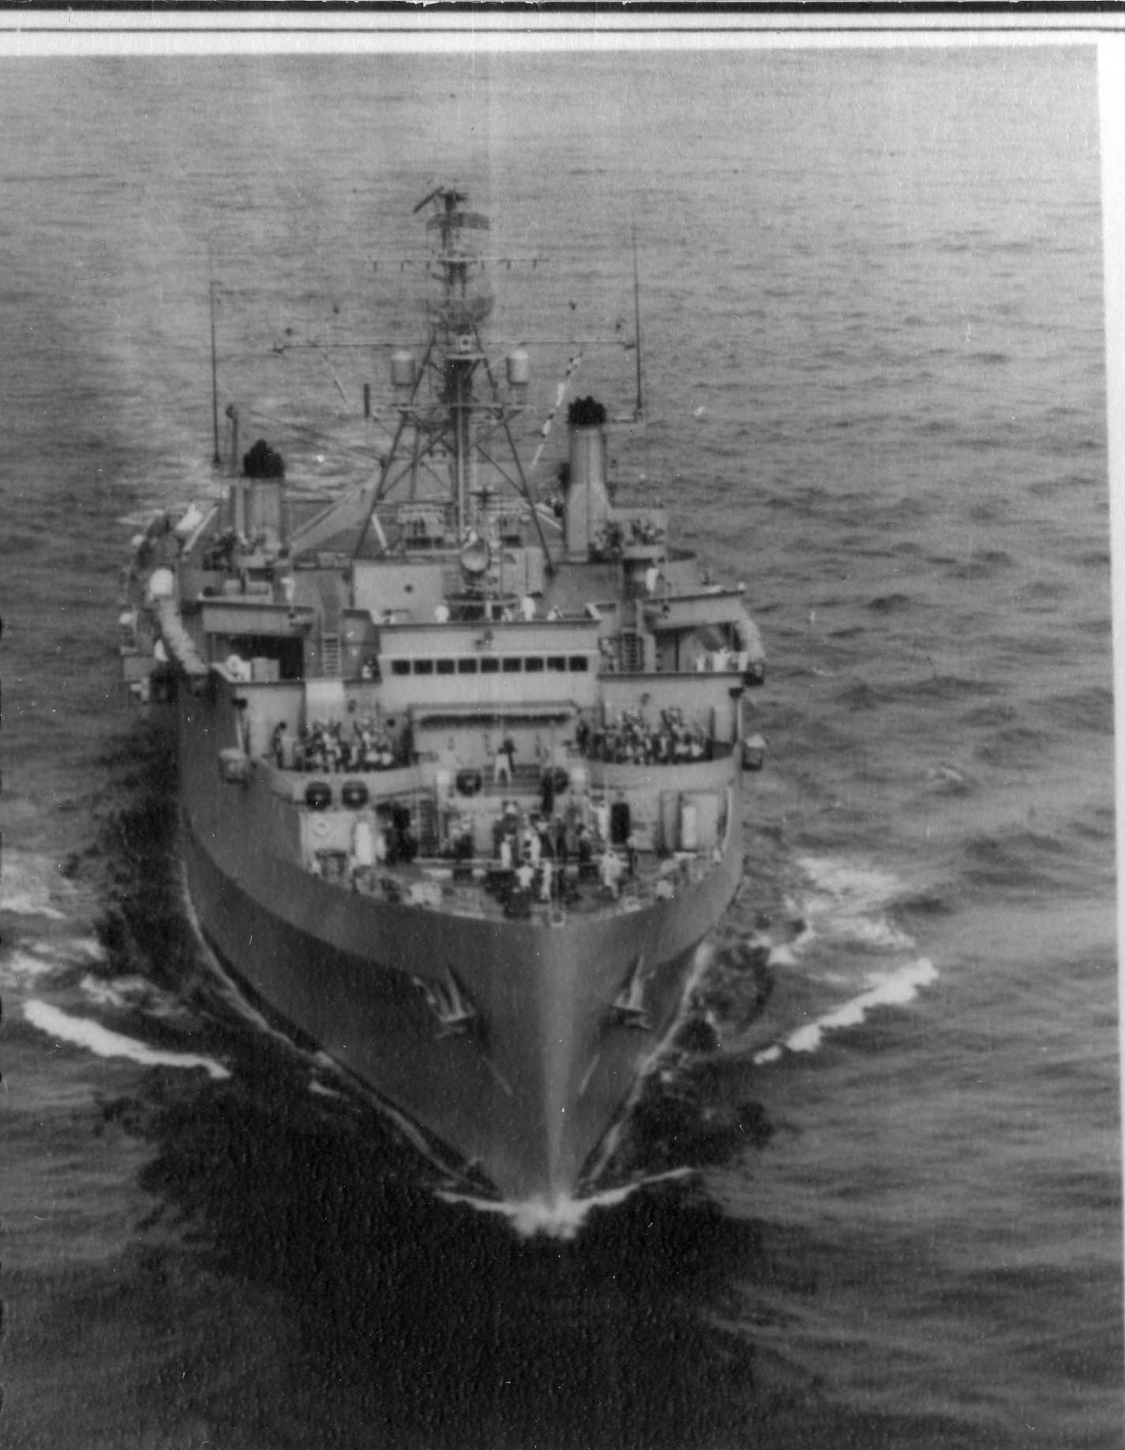USS *Vancouver* (LPD-2)**

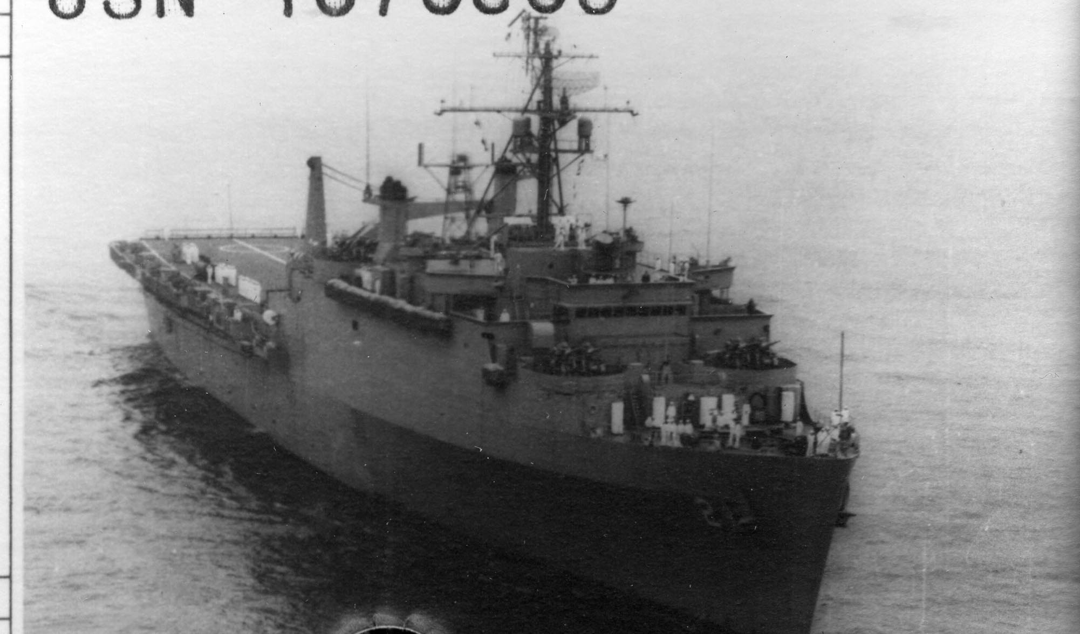

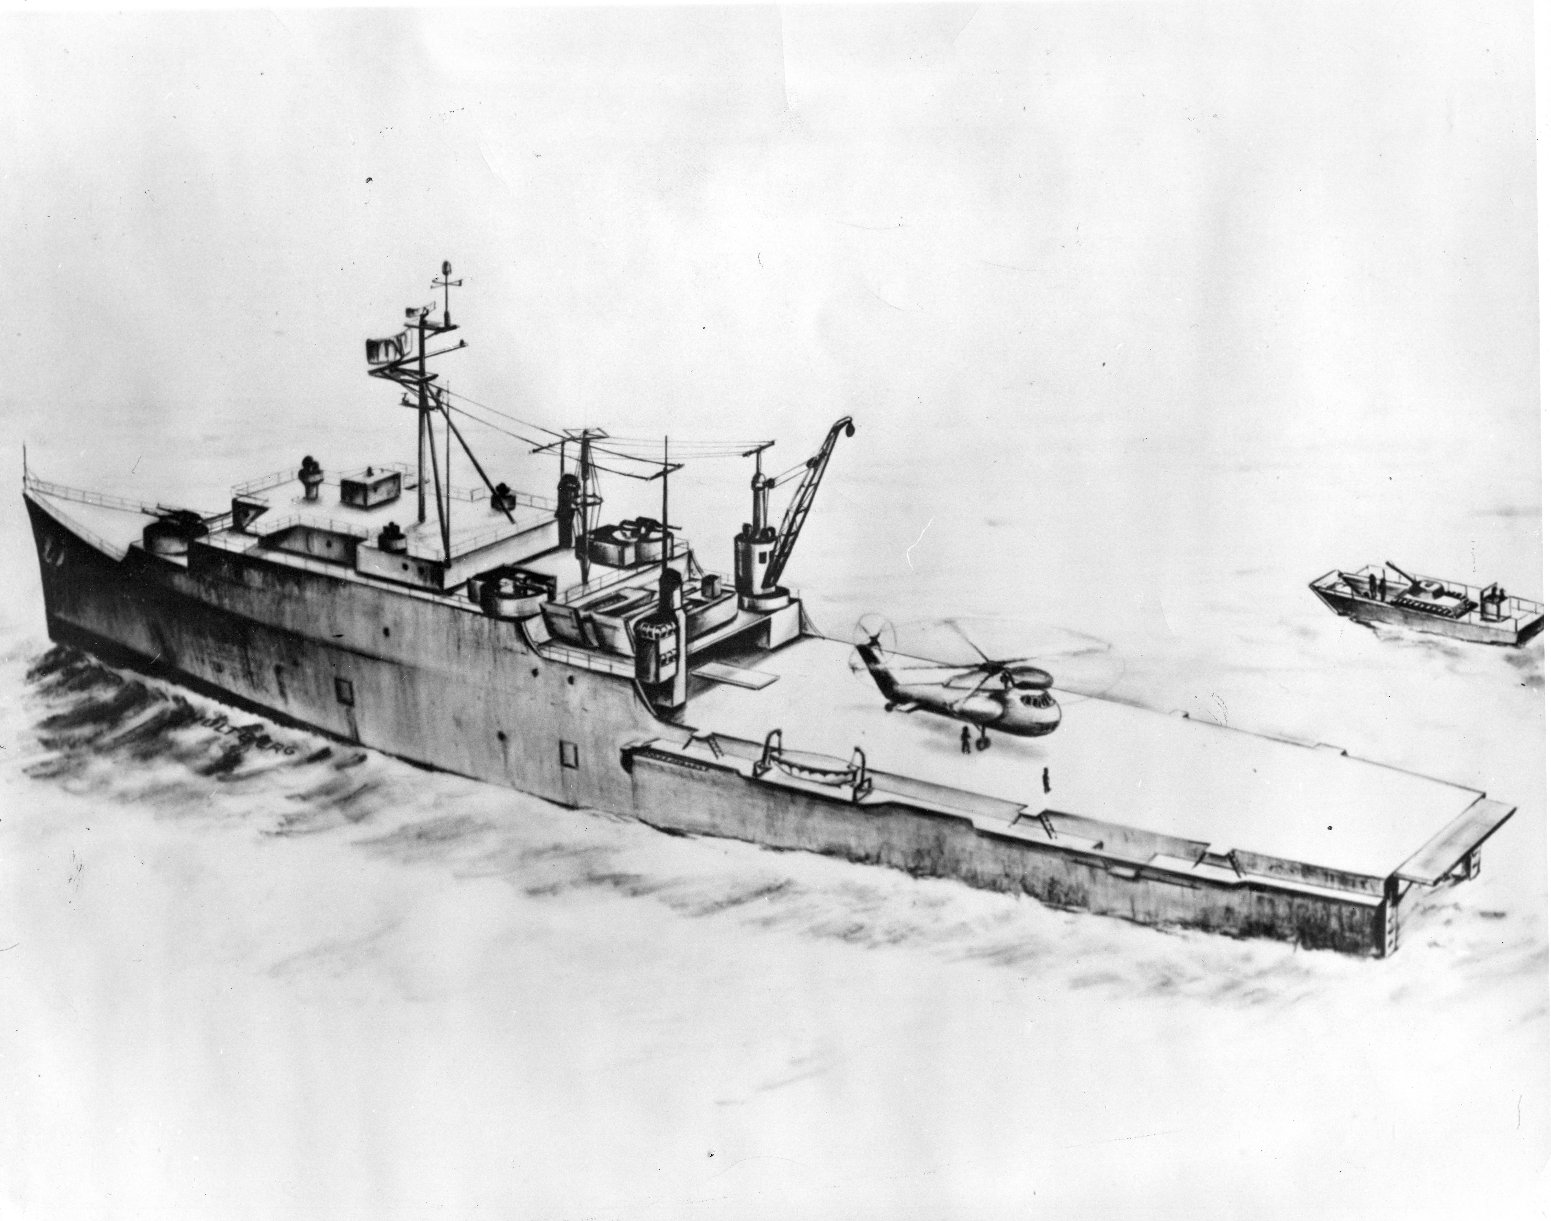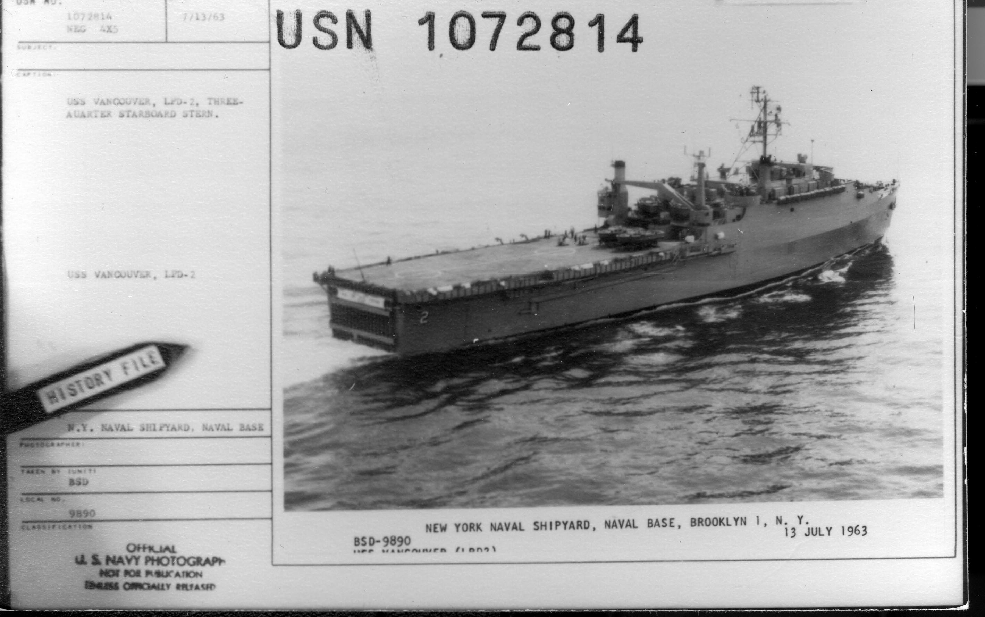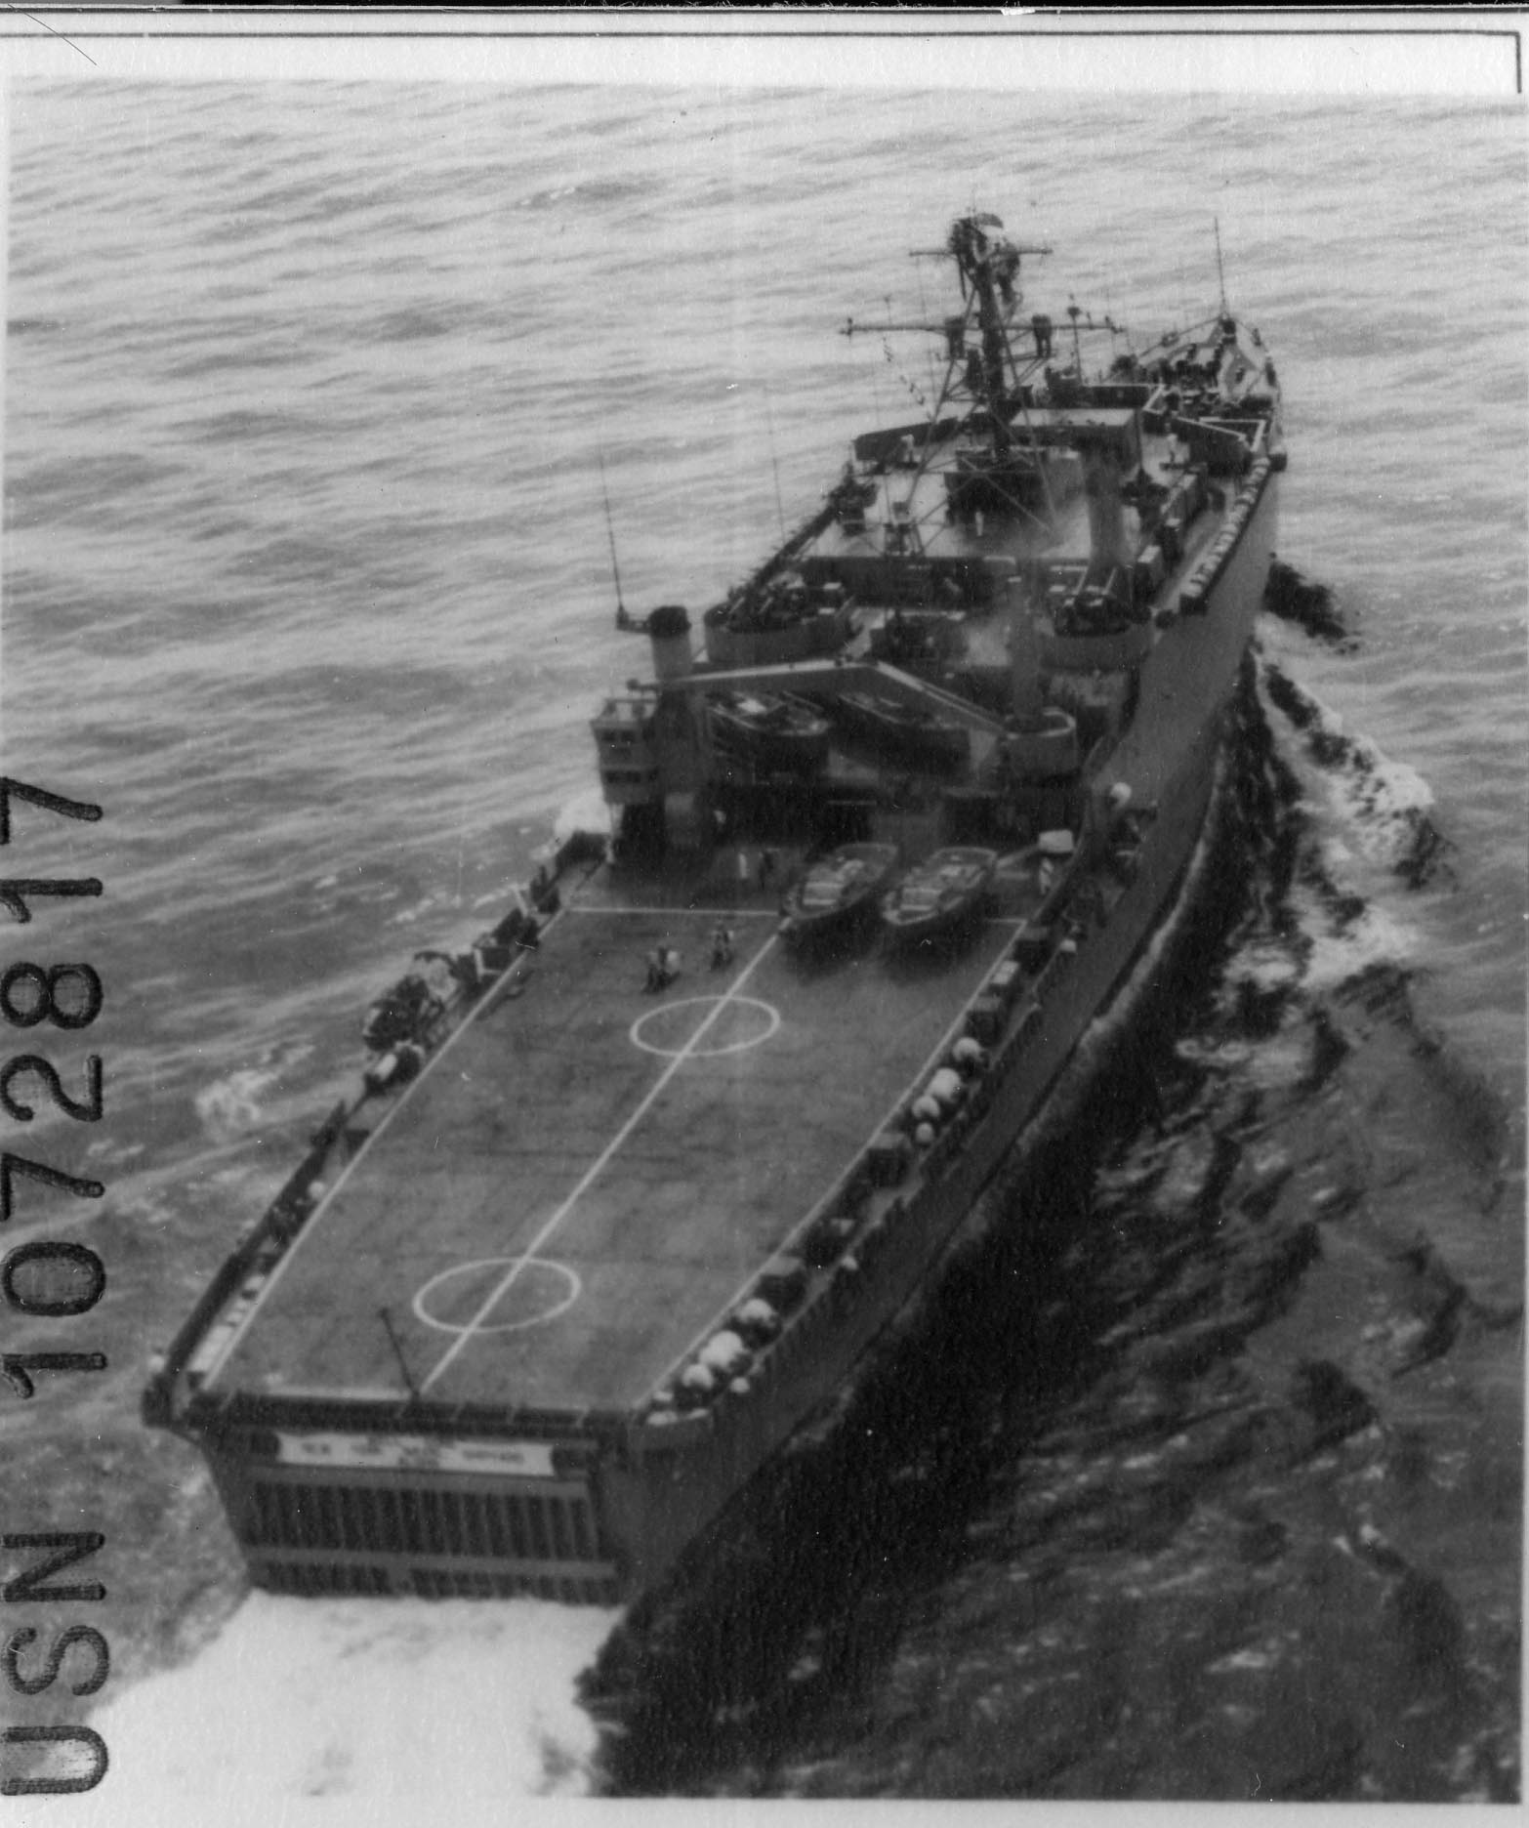

**All photos of USS *Vancouver*, other than the artist’s conception above,were taken off of New York Naval Shipyard, Naval Base, Brooklyn, New York in the summer of 1963. Photos courtesy of U.S. Navy, Naval History and Heritage Command.**

[Type a quote from the document or the summary of an interesting point. You can position the text box anywhere in the document. Use the Drawing Tools tab to change the formatting of the pull quote text box.]

[Type a quote from the document or the summary of an interesting point. You can position the text box anywhere in the document. Use the Drawing Tools tab to change the formatting of the pull quote text box.]